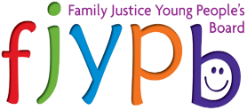
FAMILY JUSTICE YOUNG PEOPLE’S BOARD UPDATE
Cafcass Board Meeting
7th July 2021

FJYPB
- Communications
Following our update at the previous Cafcass Board meeting that we have received ministerial support for our website, we have now submitted our business case to the MoJ. We are keeping our fingers crossed that we will hear back soon with good news!

- 10 years of the FJYPB
Planning is well underway for our celebration event for our 10th anniversary. On 25th May, FJYPB members Lisa and Malak visited the Coram site where we will be hosting our celebration event in August. Malak said ‘We went to Coram in London to view the venue for the FJYPB 10th anniversary. It was a fairly short trip, but we did get to see the main outdoor venue and planned what it would look like to set up some decor and a marquee. Unfortunately, it was a rainy day so we are hopeful the actual day will be nice and summery!’

We have sent out save the dates to FJYPB members, as well as Cafcass staff who have worked closely with the FJYPB over the years, and have received responses from some of our retired members, who we are very much looking forward to seeing again!

- VOTC 2021
We will once again be hosting a series of webinars aimed at professionals throughout the October half term, as well as another webinar for Children in Care Councils. We have confirmed the theme will be on the topic of communication and language and will provide further updates on this as planning develops. Watch this space!

- FJYPB Book
We are continuing to gather our experiences for the FJYPB book. Two further workshops have been confirmed with Dawn Reeves, who is helping us to write the book. Members will be helping Dawn with the design and layout of the book, including the title. We hope to launch the book in September to mark our 10th anniversary month.

FJYPB and Cafcass
- Carers Week
As part of Carers Week on 7-11 June, FJYPB members Matthew and Plam wrote blogs which were shared with Cafcass staff via the Intranet. Matthew wrote his blog on the sacrifices he has had to make as a young carer, and Plam wrote about her advice to professionals as a young person being cared for.

- Word buster
Following the Jargon Buster workshop with Jacky Tiotto on 12th May, FJYPB member Katie presented our findings at a Leadership Live event to encourage Cafcass staff to be more mindful of their language when talking about or to children and young people.

We are currently developing a Word Busting team, which will consist of both FJYPB members and Cafcass staff. We will meet once per month, starting from the 30th June, to bust 2 words and will share these via Cafcass comms on the intranet.

- Together – Cafcass Practice Framework
At a recent Leadership Live event, we presented our thoughts on the Cafcass ‘Together’ practice framework, following a workshop with Barry Tilzey and Sarah Dickinson. FJYPB member Katie presented at the event and shared the following feedback from our workshop:

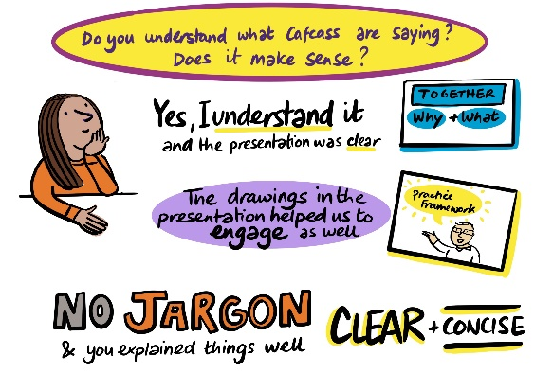
We were asked what we thought about the name ‘Together’ for the practice framework, to which we replied that we like the name as it sounds friendly and inclusive.

We were also asked if we understood what Cafcass were detailing in ‘Together’ and members said that it was clear and understandable. The pictures helped engage us and made it more interesting. Also, the language was free from Jargon which made it easy to read.

We shared our views about how we thought the new ‘Together’ practice would help children and young people. We said that it gives the child or young person more choice and to have more say in the ways they engage with Cafcass. By an FCA simply asking a child or young person where and what time do you want to meet with me.
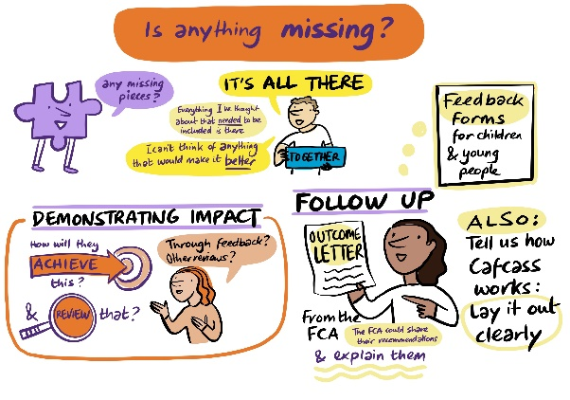
We were asked if we thought anything was missing from ‘Together’ and we suggested:
- To highlight how you will know the new framework is having an impact, we suggested through feedback from children and young people.
- For all FCA’s to share a good-bye or outcome letter with the children they have supported. To include where they can go to for support in the future.
- For all FCA’s to share their recommendations to court with children and gain their views on them before their reports are submitted to court.
- To explain to children and young people how Cafcass helps children and families, how long they are likely to be involved for and what happens afterwards.

- Voices in care
We met with Jacky Tiotto and Sarah Parsons and representatives from Hertfordshire and Essex Local authorities on 14th June to discuss how to identify ways in which final evidence and emerging evidence with a child or young person during care proceedings. It was agreed that we will host a workshop and invite children and young people representatives from Hertfordshire, Essex and Sheffield on August 13th to draft a universal fact sheet for children when they enter care proceedings. Following the workshop, we will consider:
- How do we routinely give children the opportunity to have their voice heard?
- How is their voice recorded?
- How do professionals check that children and young people understand what is happening?
- How do we present this to court?
FJYPB and the wider sector
- Cafcass Cymru – We recently met with Nigel Brown, CEO at Cafcass Cymru to discuss our attendance at Advisory Committee Meetings, and other exciting future projects to work on together. We also joined a Development Day for Cafcass Cymru staff to give a presentation on who we are and some of our recent work.
- DfE – FJYPB members Ayla and Marina have been hosting workshops to discuss content ideas for a PHSE lesson on family relationships and family justice. We will be presenting this to the DfE at our catch-up meetings and we hope to get their agreement for this to be shared in schools.
- Health and Wellbeing Alliance: Reducing Parental Conflict – We have recently been involved in the development meetings for the HWA’s Reducing Parental Conflict toolkit. This toolkit has now been completed and features a video from some of our FJYPB members to parents on why it is important to understand the impact of parental conflict on a child.
- CYP Now Awards – The Children and Young People Now awards are once again taking entries for 2021! We will be applying for the Family Justice Award again, following our submission last year being congratulated as a highly commended finalist.
- Transparency Review – Following our oral discussion with the President of the Family Division in May, we once again have been looking at transparency within the courts, following the report published by CORAMBAAF on the anonymisation of children’s judgments in cases involving sexual abuse being on BAILLI, a public website. We will be presenting at the roundtable discussion on 13th June to give our views directly to senior judges and professionals in response to the report.

Forward Look
- 12th August 2021 – Next FJYPB meeting

