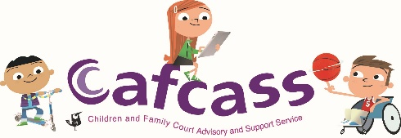
Raising a concern with Cafcass
Although we try hard to provide high quality services to children and their families, we know that sometimes you might be unhappy with the way we have worked with you.
Information about our complaints process is available on our concerns and complaints website page. If you are a young person, please read our page for you.
If you disagree with our advice to the court in a safeguarding letter, recommendations in a court report, or the professional assessment set out in either, please raise your concerns in court where they can be explored. These types of concerns can only be addressed within court and not as part of our complaints process.
We encourage children and families to raise their concerns while we are still involved in the case so that, wherever possible, concerns are drawn to the attention of the court before proceedings conclude. If you feel able to, it would be beneficial for you to discuss any concerns with your allocated Family Court Adviser in the first instance.
To help us to resolve your concern as quickly as possible, please complete the form below. We hope this form will help you to set out the main reasons for contacting us. Please try to provide a summary of the main points rather than excessive information. There will be an opportunity for you provide further information to Cafcass later on.
Your Full Name
Your Cafcass Case Reference Number
(if known)
Your Email Address
Your Phone Number
Your Address

Your Concern - If possible, please select the main reason for your concern from the list below;
I feel Cafcass have been biased
I have a concern about my allocated Family Court Adviser or Children’s Guardian
I am concerned that incorrect information has been used in my case
There have been delays in responding to me
There has been a lack of communication with me
I am unhappy with the report that has been sent to the court
Other
Please provide a summary of the concern you would like to talk to us about. (Please try to keep the summary brief so that we can respond promptly. – you will be able to provide more information later in the process as needed)

Have you spoken to or contacted anyone at Cafcass about this concern already? If yes – please provide the name of the person or team you have spoken to.

Is your concern related to a current court case or has the case ended? If the case has ended, how long ago did it end?

Please tell us how you would like this concern to be resolved.

We really want to work with you to resolve any concerns you may have as quickly as possible. This form is the first step.
There are several ways that you can share this form with us;
- Email it to us via Customerfeedback@cafcass.gov.uk
- Complete a contact us form on our website – www.cafcass.gov.uk and attach the file to the contact us form you have been kind enough to fill out
- Post the printed form to Customer Feedback, Cafcass Post, PO BOX 5076 Slough SL1 0RX
Please do call us on 0300 456 4000 if you have any questions or need any help with completing and sending this form to us.
Thank you for taking the time to raise your concerns with Cafcass. Feedback is important to enable us to learn how to improve our service to those children and families going through Family Court Proceedings which we recognise can be a stressful and emotional experience for all involved.

